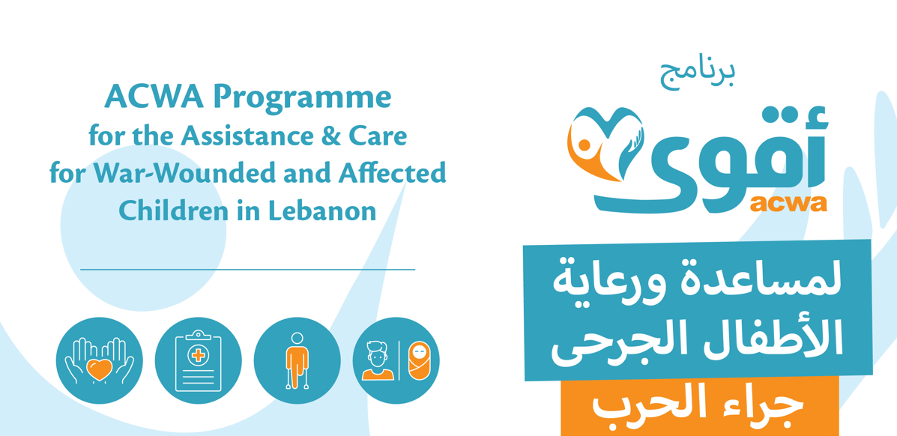

PROSTHESIS UPDATE
FIANZ Support under the ACWA Programme
May 2026
Specialized prosthetic rehabilitation and multidisciplinary care for war-injured children.

Overview of Support
Under the broader ACWA Programme, UNICEF, the Ministry of Public Health, the Ghassan Abu Sittah Children's Fund, INARA, and Wings for Hope are supporting war-injured children through a comprehensive model of care that includes medical treatment, rehabilitation, prosthetic support, psychosocial care, and long-term follow-up.
FIANZ support has contributed to a highly specialized area of care for pediatric amputees, where each case requires an individualized pathway based on the child's injury, age, surgical readiness, mobility goals, and long-term rehabilitation needs.
Through this support, children with complex upper limb, lower limb, partial foot, finger, and partial hand amputations have been able to access prosthetic and orthotic interventions, physiotherapy, follow-up adjustments, and preparation for future fittings. Five children have already received prosthetic or orthotic devices, while seven others continue to receive surgical and rehabilitation support to ensure they are clinically ready for the next stage of care.
12  children covered in this update | 5  prosthetic or orthotic devices fitted | 7  children in surgical and rehabilitation preparation

Financial Utilization
To date, funding has been utilized for prosthetic, orthotic, and physiotherapy services, including fabrication and fitting, socket adaptation, high-activity prosthetic components, rehabilitation preparation, maintenance, follow-up adjustments, and monitoring. Based on current clinical assessments, continued resources are required to sustain care for children supported through this component.

Interventions fitted to date
Ali K  Below-elbow cosmetic + mechanical prosthetic | Mohamad H  Below-knee prosthetic | Hussein S  Below-knee prosthetic | Fatima J  Partial foot orthotic | Hussein M  KAFO + GRAFO orthotic

Case Studies
Ali K  Traumatic below-elbow amputation  Ali was three years old at the time of injury. His rehabilitation pathway uses a phased model that gradually introduces more advanced prosthetic systems over time.  Support provided  • Cosmetic prosthetic fitting  • Occupational therapy  • Physical rehabilitation  • Prosthetic acceptance training  Current status  Ali continues occupational and physical therapy under close monitoring. After six to nine months of training and rehabilitation, he is expected to progress toward myoelectric prosthetic fitting. | Mohamad H  Below-knee amputation  Mohamad is a young active patient who sustained a below-knee amputation after being shot in South Lebanon. Due to his mobility goals and activity level, he required a high-activity prosthetic solution.  Support provided  • Clinical mobility assessment  • Prosthetic alignment  • Rehabilitation monitoring  • Adaptation support  • Continuous follow-up  Current status  Mohamad continues rehabilitation and monitoring. His prosthetic is being re-adapted following additional surgeries to support continued functionality.

Looking Ahead
As new injuries continue to be reported, sustained donor support remains critical to maintaining this specialized continuum of care. Continued support will help children access surgical interventions, advanced prosthetic fitting where clinically appropriate, physiotherapy, occupational therapy, psychosocial support, and long-term follow-up.
Together, this support helps war-affected children recover mobility, independence, functionality, and quality of life.

