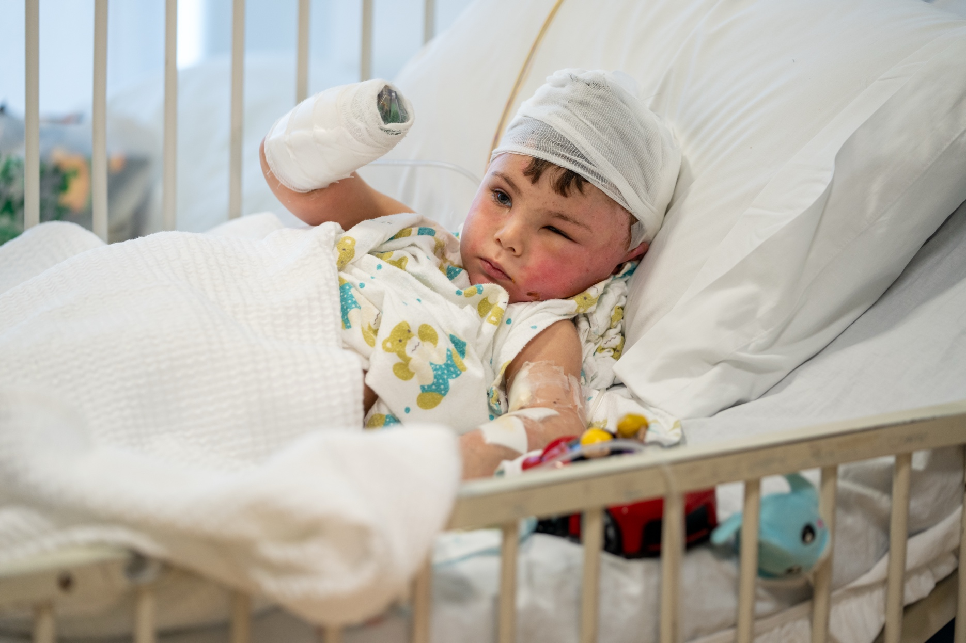

UNICEF Lebanon: Addressing the Needs of War-Injured Children in Lebanon

The Situation:
Children in Lebanon are struggling to recover from a devastating war. The use of advanced weaponry during the war, such as white phosphorous and heavy bombs, and use of explosive weapons in heavily populated areas resulted in severe injuries to children which require specialized care beyond the capacity of most local hospitals. Children injured in the war are now suffering from severe burns, fractures, loss of limbs and other life-altering conditions requiring urgent and specialized medical attention. Many have also experienced profound psychological trauma, particularly those who have lost family members and been uprooted from their homes.
The war has also devastated Lebanon’s fragile healthcare system, with 40 hospitals damaged and 98 primary healthcare centers (PHCCs) closed, disrupting access to care for thousands of families now in urgent need of services and leaving children even more vulnerable to health issues.

Our Response:
War-related injuries, such as burns and limb loss, often necessitate reconstructive surgeries and specialized medical interventions that are not commonly available and affordable for most families. This includes surgical care, prosthetics, long-term physiotherapy, and other specialized rehabilitation services.
Without specialized support, these children are at risk of being unable to lead productive and fulfilling lives. Some of the injured children will also require lifelong care due to disabilities caused by the war or mental health support for the traumas they experienced.
Recovery efforts must put children first: From Lebanon, UNICEF has recently launched a comprehensive, multi-sectoral response implemented through a consortium of specialized partners, including Ghassan Abu Sittah Children's Fund, which has been treating critically injured children and the International Network for Aid, Relief and Assistance (INARA), which provides services to address the most urgent and most pressing needs of children in communities impacted by war. As part of this effort, an assessment of the Ministry of Public Health (MoPH) database of 1,500 children affected by war is underway to identify urgent needs and ensure targeted support. The contribution from Federation of Islamic Associations of New Zealand (FIANZ) is supporting this urgent and critical effort. The response is currently prioritizing 300 children, with 74 requiring specialized medical care due to war-related injuries. Two hospitals have been engaged, the American University of Beirut (AUB) hospital and the Turkish hospital selected specifically for their advanced expertise in specialized medical services.

The consortium delivers a coordinated response combining four key components:


- Specialized medical treatment for children with severe war-related injuries, including reconstructive surgeries and trauma care.
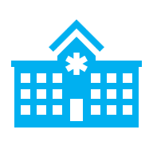
- Post-hospitalization follow-up to monitor recovery, ensure reintegration into daily life, provide continued care and facilitate access to the National Disability Allowance (NDA) financial support.
- Additional support for psychosocial needs, physiotherapy and referrals to specialized mental health services. To facilitate access to essential these and other medical services, transportation support will also be provided to children and their families,

- The consortium will also map and engage other actors and service providers across the country to create a robust referral network for needs such as rehabilitation, educational support, and other critical services, ensuring that the diverse needs of injured children and their families are comprehensively addressed.

Needs:
Nearly 1,800 children affected by the war have been identified in an existing medical record database established by the MoPH.

Within this database, an estimated 1,500 children have sustained injuries. With average medical care costs estimated at US$ 7,000 per moderate case and US$ 25,000 per severe case, additional support is urgently needed to provide critical care for more children. The children need urgent support to heal, rebuild their lives, and survive the lasting impacts of this crisis.

UNICEF in Action:
 | 68 surgeries were performed for 43 children with 16% undergoing 2 or more surgeries.
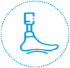 | 15 children (10%) require prosthetics
 | 11% have disabilities, with more than a third requiring assistive devices. These include physical, intellectual, vision, speech, and hearing disabilities.
 | 82% children reported difficulties in performing daily activities due to their physical injury, including difficulties in eating, drinking, selfcare, toileting, walking, learning, communicating and playing with peers.
 | 60% suffer from more than 1 injury, with 36% suffering from two different injuries and 24% suffering from 3 different injuries.

Scope of Support
- Comprehensive assessments determine medical, physical, and psychological needs.
- High-quality prosthetics and fittings, with continuous adjustments as children grow.
- Holistic rehabilitation plans, including physiotherapy, psychosocial support, and social reintegration.
- Family counseling and follow-up to empower parents and ensure sustained well-being.

Overview of Support from FIANZ
Under the broader ACWA Programme, UNICEF, the Ministry of Public Health, the Ghassan Abu Sittah Children's Fund, INARA, and Wings for Hope are supporting war-injured children through a comprehensive model of care that includes medical treatment, rehabilitation, prosthetic support, psychosocial care, and long-term follow-up.
FIANZs support has contributed to a highly specialized area of care for pediatric amputees, where each case requires an individualized pathway based on the child's injury, age, surgical readiness, mobility goals, and long-term rehabilitation needs.
Through this support, children with complex upper limb, lower limb, partial foot, finger, and partial hand amputations have been able to access prosthetic and orthotic interventions, physiotherapy, follow-up adjustments, and preparation for future fittings. Five children have already received prosthetic or orthotic devices, while seven others continue to receive surgical and rehabilitation support to ensure they are clinically ready for the next stage of care.
12  children covered in this update | 5  prosthetic or orthotic devices fitted | 7  children in surgical and rehabilitation preparation

Financial Utilization
To date, funding has been utilized for prosthetic, orthotic, and physiotherapy services, including fabrication and fitting, socket adaptation, high-activity prosthetic components, rehabilitation preparation, maintenance, follow-up adjustments, and monitoring. Based on current clinical assessments, continued resources are required to sustain care for children supported through this component.

Fitted Interventions as at May 2026
Ali K  Below-elbow cosmetic + mechanical prosthetic | Mohamad H  Below-knee prosthetic | Hussein S  Below-knee prosthetic | Fatima J  Partial foot orthotic | Hussein M  KAFO + GRAFO orthotic

